Calculator Assumed
Exponential Functions and Graphs

Time: 45 minutes
Total Marks: 45
Your Score: / 45



Question One: [3, 2, 2, 2 =9 marks]
Consider the following functions:
- State all the equations that represent exponential functions.

- State the two equations which represent the same exponential function.

- State the equations which represent increasing exponential functions.

- State the equations which represent decreasing exponential functions.
Question Two: [2, 2, 2, 2 = 8marks]
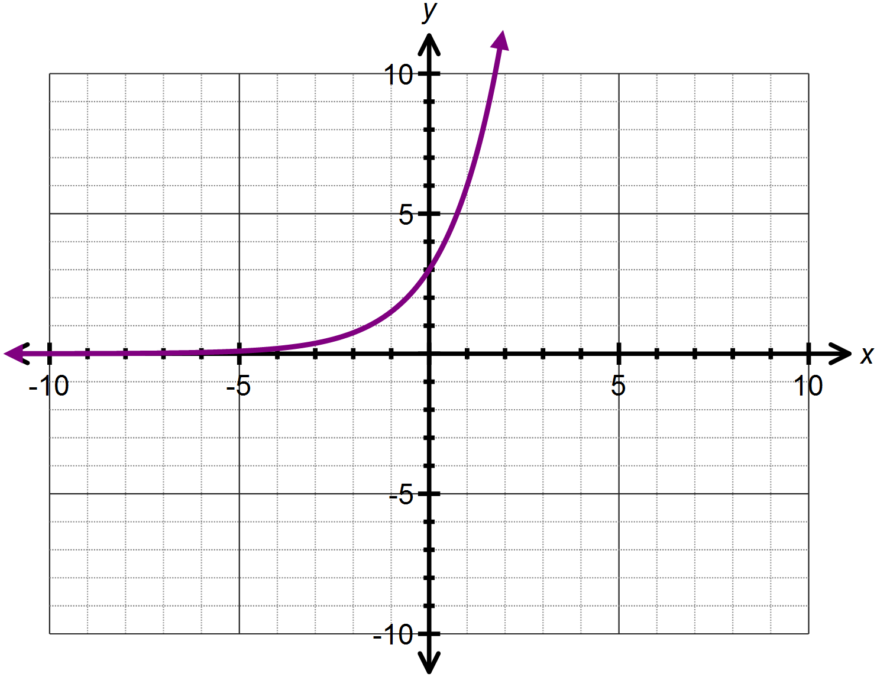Consider the graph of drawn below.

- Determine the equation of the function .

- State the domain and range of .

- Describe how the function is transformed from .

- Sketch on the axes above.

Question Three: [4, 5 = 9 marks]
Consider the function

- State the equation of the horizontal asymptote.

- If the function is translated 4 units down, state the equation defining the new function.

- Using your answer to part (ii) or otherwise, state the equation of the asymptote for the newly translated function.

- State the coordinate for the y-intercept of the newly translated function.

- If the function is translated 2 units left, determine:
- Two equivalent expressions which define the newly translated function.

- Where the y- intercept has been translated to.

- The y – intercept of the newly translated function.

Question Four: [2, 2, 2, 2, 3, 3 =14 marks]
Determine the equation of each of the following functions:
- 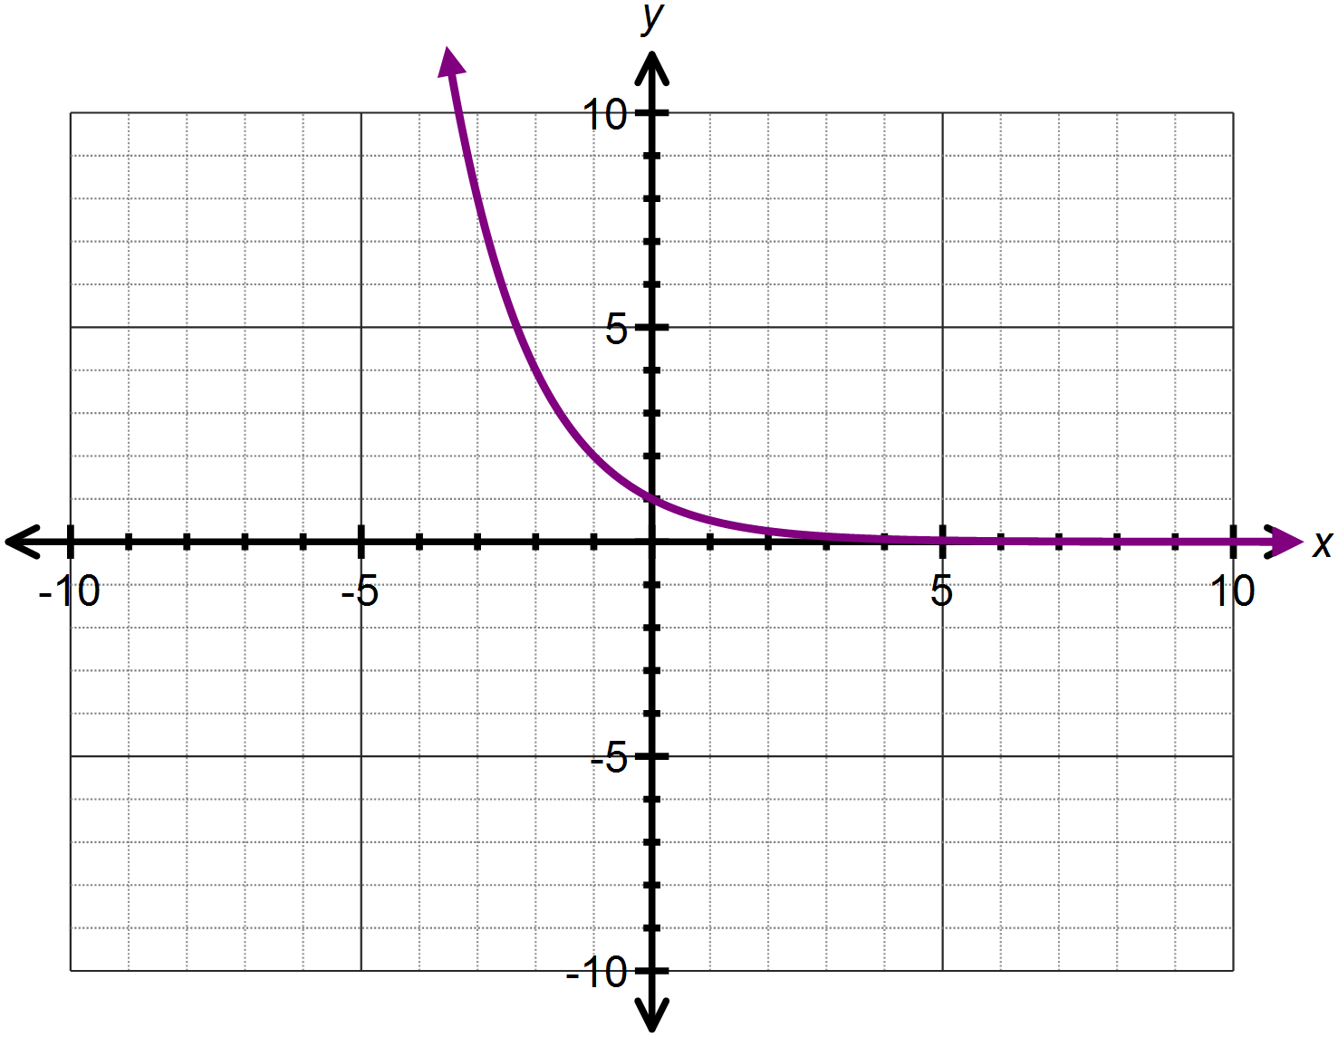

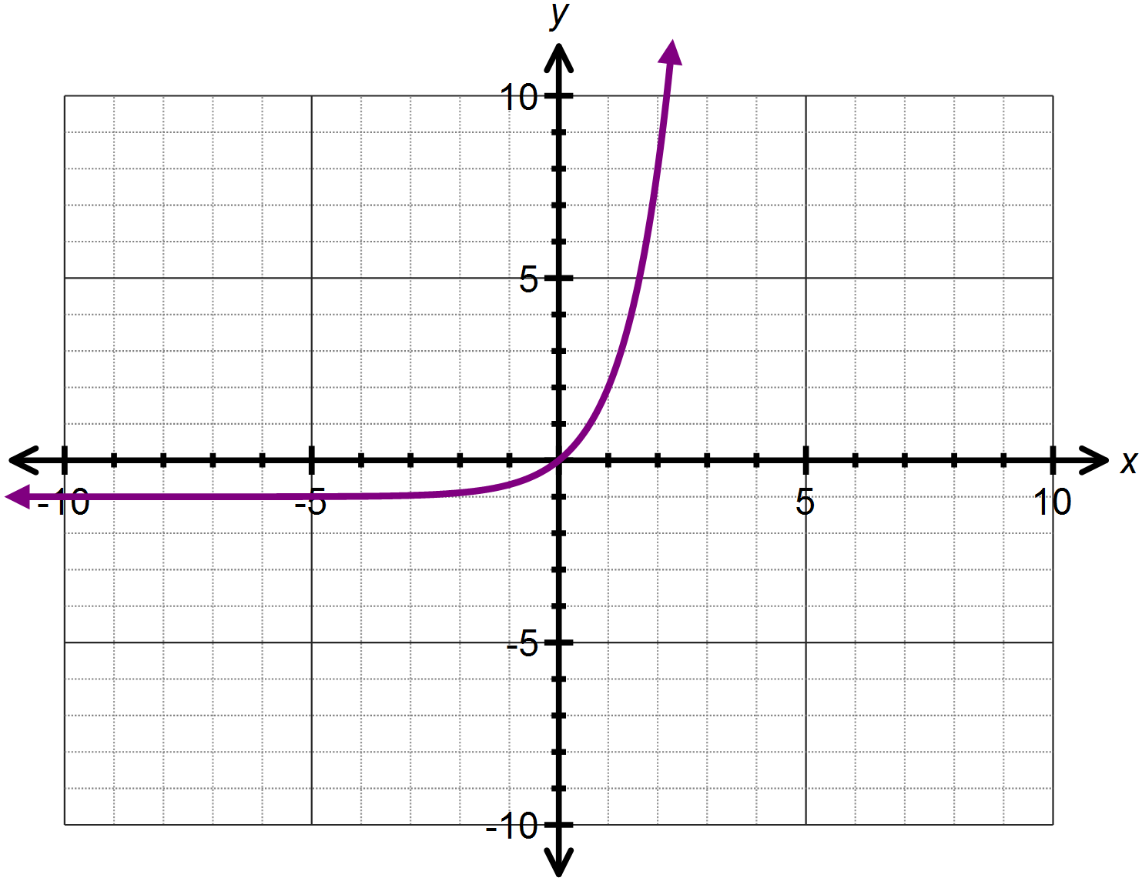

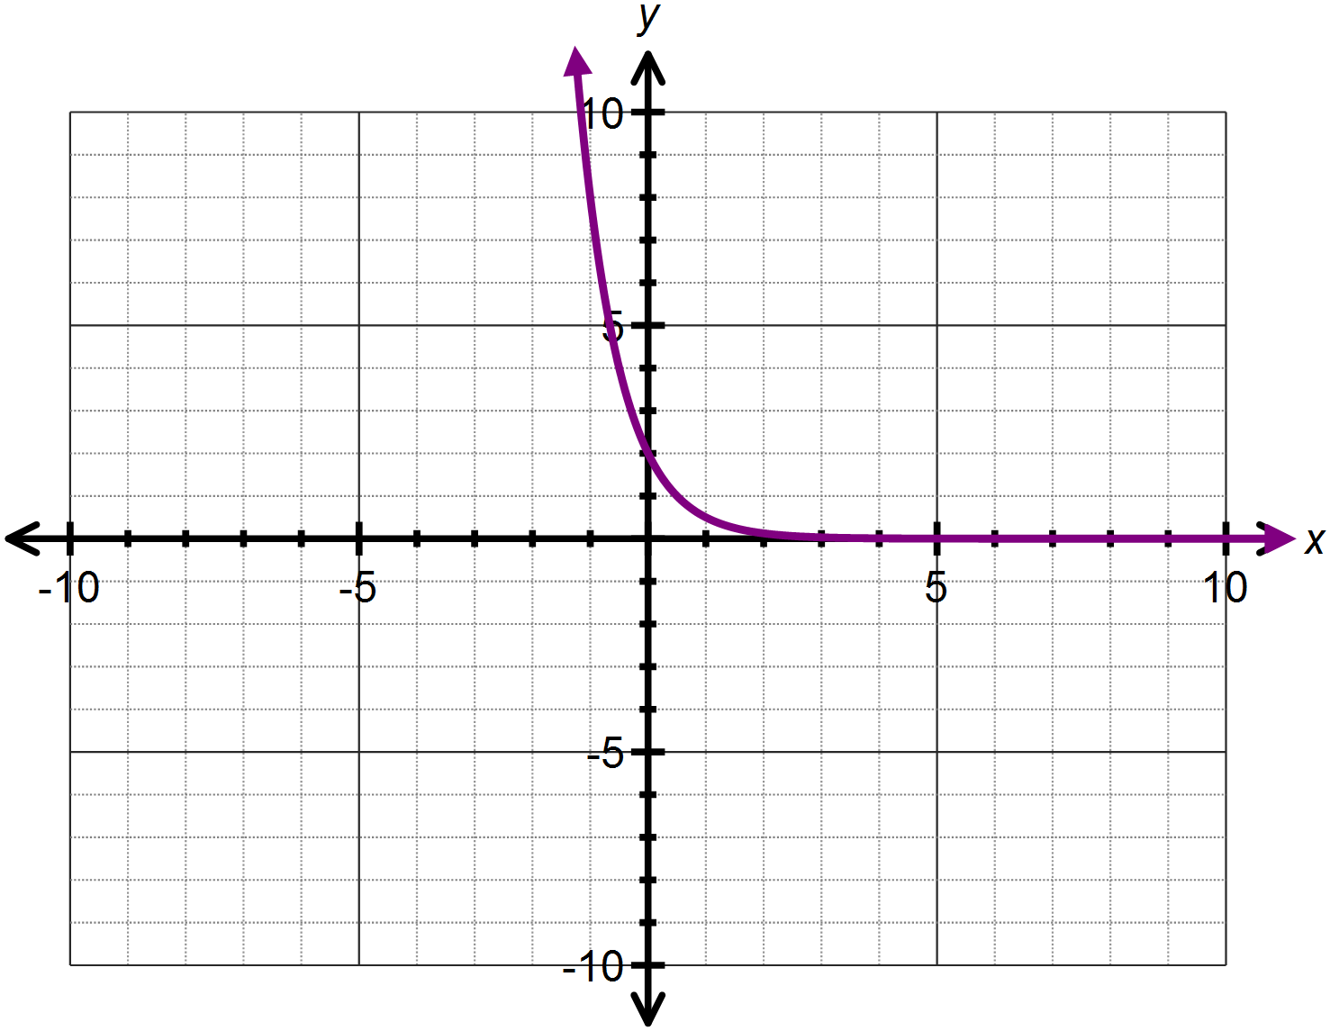

- 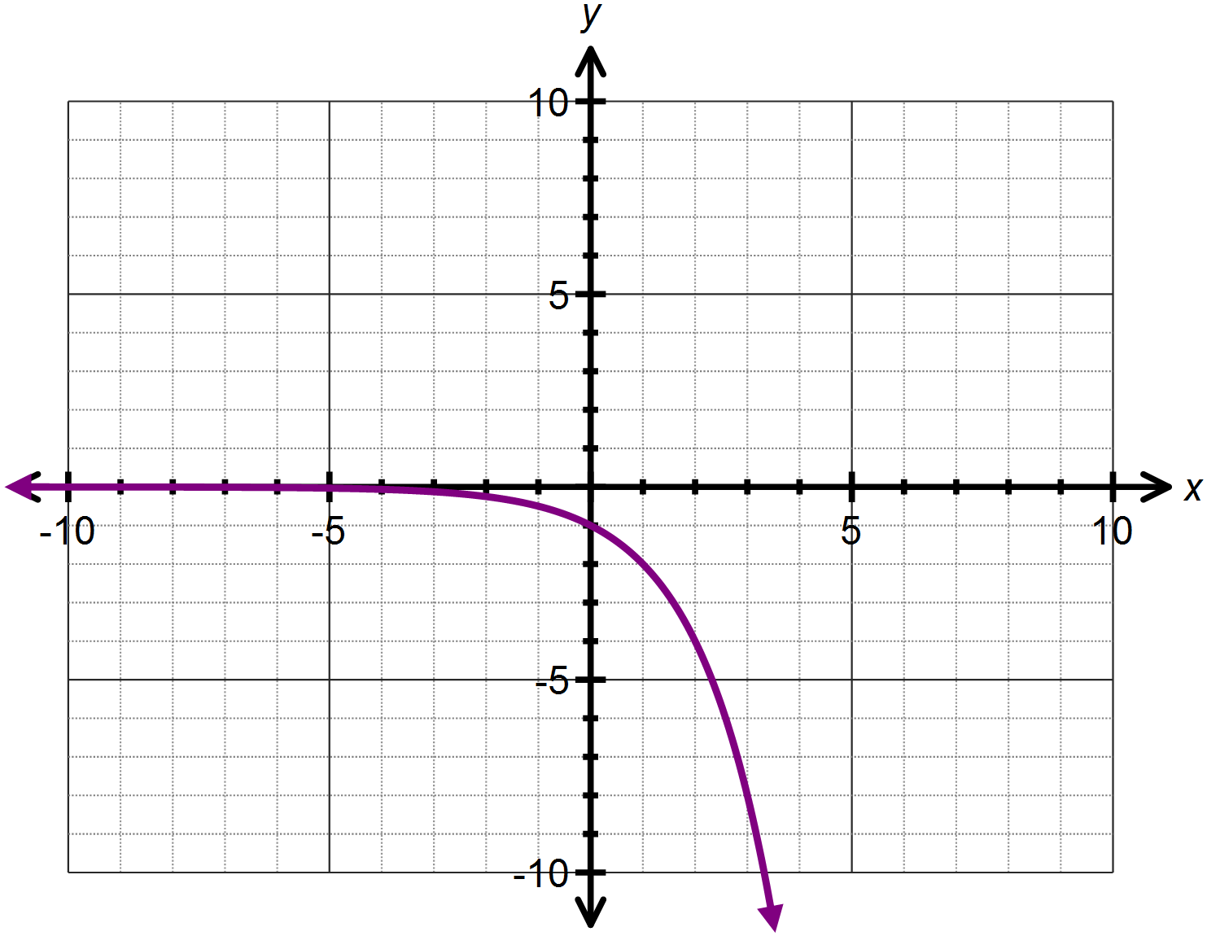

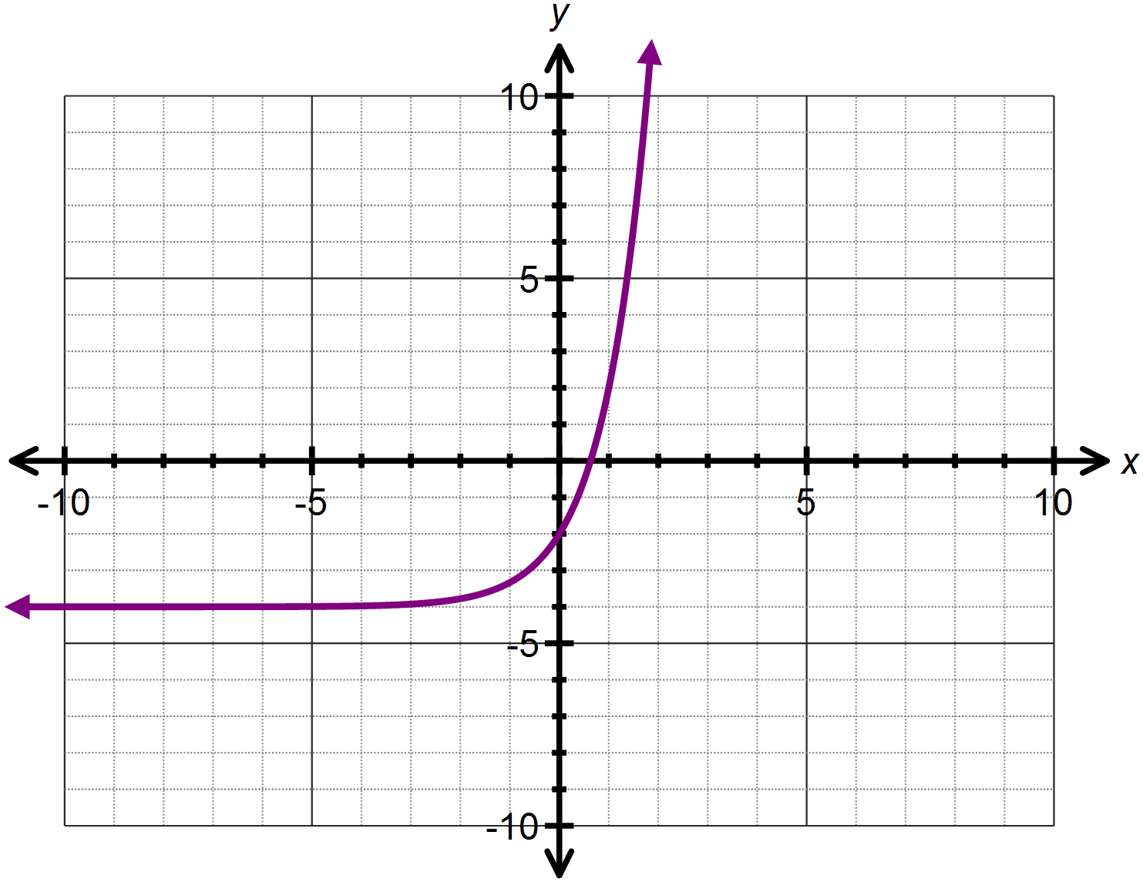

- 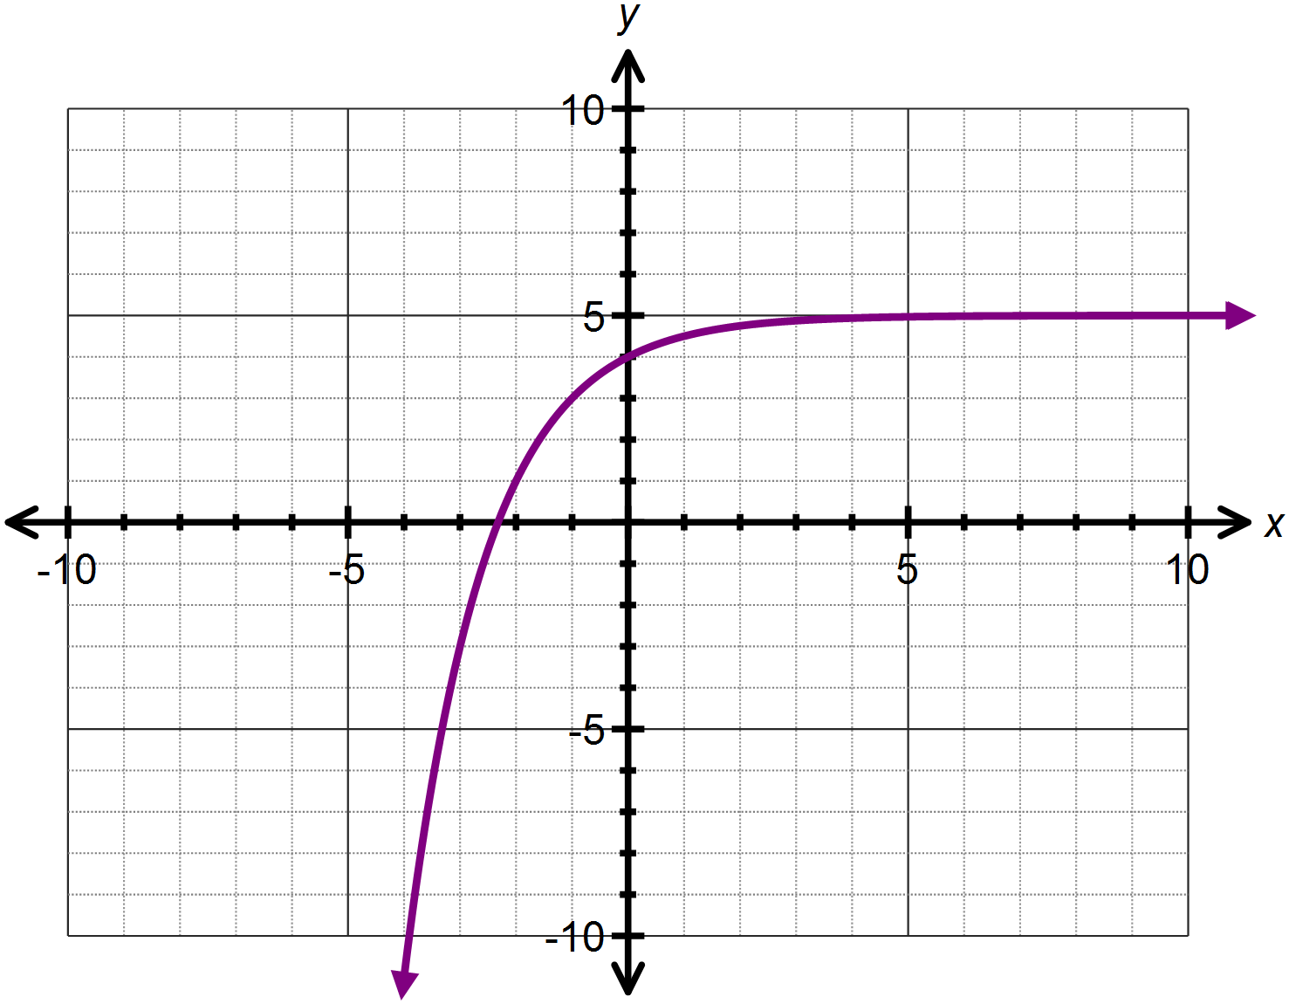

Question Five: [2, 2, 1 = 5 marks]
The function has been transformed and now has equation
- Describe the two transformations that have occurred.

- These two transformations are the equivalent of one single transformation. State the single transformation which results in the same function.

- Hence or otherwise determine the y – intercept of the transformed function.

SOLUTIONS
Calculator Assumed
Exponential Functions and Graphs

Time: 45 minutes
Total Marks: 45
Your Score: / 45



Question One: [3, 2, 2, 2 =9 marks]
Consider the following functions:
- State all the equations that represent exponential functions.




- State the two equations which represent the same exponential function.




- State the equations which represent increasing exponential functions.



- State the equations which represent decreasing exponential functions.



Question Two: [2, 2, 2, 2 = 8marks]
Consider the graph of drawn below.




- Determine the equation of the function .



- State the domain and range of .



- Describe how the function is transformed from .



- Sketch on the axes above.

Question Three: [4, 5 = 9 marks]
Consider the function

- State the equation of the horizontal asymptote.

- If the function is translated 4 units down, state the equation defining the new function.



- Using your answer to part (ii) or otherwise, state the equation of the asymptote for the newly translated function.
- State the coordinate for the y-intercept of the newly translated function.


- If the function is translated 2 units left, determine:
- Two equivalent expressions which define the newly translated function.





- Where the y- intercept has been translated to.

- The y – intercept of the newly translated function.

Question Four: [2, 2, 2, 2, 3, 3 =14 marks]
Determine the equation of each of the following functions:


- 











- 










- 


Question Five: [2, 2, 1 = 5 marks]
The function has been transformed and now has equation

- Describe the two transformations that have occurred.


- These two transformations are the equivalent of one single transformation. State the single transformation which results in the same function.



- Hence or otherwise determine the y – intercept of the transformed function.


